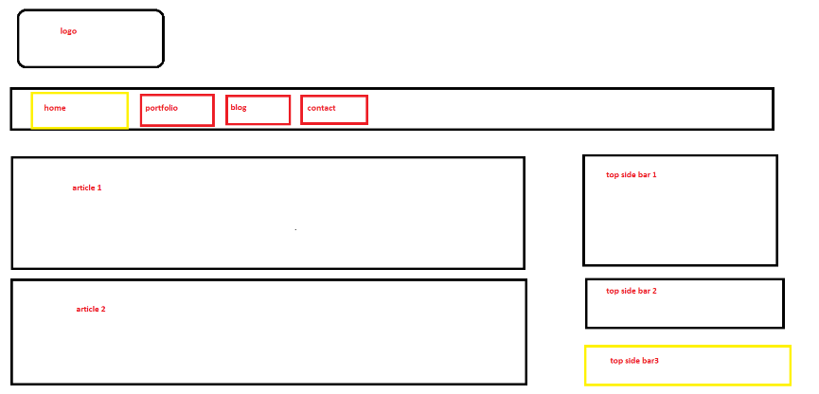

Step 1:

* One Header
* Two Articles
* One Side-bar Navigation
* One Featured Panel
* One Footer

Step 2 : prototype of above using html 5

<!DOCTYPE html>

<html lang="en">

<head>

<title>CSS3 Website Step by Step Tutorial</title>

<meta charset="utf-8" />

</head>

<body>

<header>

<nav><ul>

<li><a href="#">Home</a></li>

<li><a href="#">News</a></li>

<li><a href="#">About Us</a></li>

<li><a href="#">Contact Us</a></li>

</ul></nav>

</header>

<div>

<div>

<article class="Top">

<header>

</header>

<footer>

</footer>

<content>

</content>

</article>

<<article class="Bottom">

<header>

</header>

<footer>

</footer>

<content>

</content>

</article>

</div>

<aside>

<h2>Navigation</h2>

<ul>

<li><a href="">Home</a></li>

<li><a href="">News</a></li>

<li><a href="">About Us</a></li>

<li><a href="">Contact Us</a></li>

</ul>

</aside>

<aside>

<div>

<h2>Featured</h2>

</div>

</aside>

</div>

<footer>

<p>Copyright © 2020 - www.kites.com</p>

</footer>

</body>

</html>

| **Tag** | **Description** |
| --- | --- |
| <header> | It is used to group the header elements like logo, navigation, etc. |
| <article> | It is used to group elements into a section, it is mostly used in blogs to enclose articles inside <article> tag. |
| <aside> | It is used to group elements like side-bar navigation, etc. Anything that goes on the side can be put inside this tag. |
| <nav> | It is used to create a group of navigation links. |
| <footer> | It is used to group the footer elements like copyright, etc. |

Step 3: add class attributes for styling

<body class="body">

<header class="pageHeader">

<li class="active">

<div class="Main">

<div class="content">

<article class="Top">

<article class="Bottom">

<aside class="top-sidebar">

<aside class="bottom-sidebar">

<footer class="pageFooter">

A rough prototype is done after this.

**Applying CSS :**

Step 1: content,body and sidebars

/* Website body */

body {

clear: both; /* Clears float value */

margin: 50px auto;

width: 80%;

text-align: left;

background-color:#EEE; /* Sets background color to light grey */

}

Then we can set the layout for articles and sidebars

/* Main content area - Articles and Side-bars */

.Main {

background-color:#FFF; /* Sets background color to White */

border-radius:5px;

overflow: hidden;

line-height: 30px;

}

/* Article contents */

.content {

padding-left:2%;

}

Once the above part is done it looks normal

Step 2: navigation

**Next is for navigation:**

/* Navavigation Bar */

.pageHeader nav {

background: #2BA6CB; /* Sets light blue background */

height: 40px; /* Sets the height to 40px, otherwise the nav bar will look like a line */

line-height: 30px; /* It makes the links to appear in the middle */

margin: 0 auto 30px auto;

text-align: center;

border-radius: 5px; /* Rounded Corner */

-moz-border-radius: 5px; /* For Mozilla browsers, same rounded corner */

-webkit-border-radius: 5px; /* FOr Safari 5 and below, same rounded corner */

}

**CSS3 style is applied to the links inside nav bar**

pageHeader nav ul {

margin: 0 auto;

}

/* Styles for Links */

.pageHeader nav ul li {

float: left;

display: inline; /* Makes the links to display horizontally */

}

.pageHeader nav a:link, .pageHeader nav a:visited {

color: #fff; /* Sets the color of the links to white */

display: inline-block; /* Makes the links to be displays as blocks */

height: 30px;

padding: 5px 23px; /* Sets space between links */

text-decoration: none;

}

**CSS3 style is applied to the link hover and link active properties:**

.pageHeader nav a:hover, .pageHeader nav a:active,

.pageHeader nav .active a:link, .pageHeader nav .active a:visited {

background: #2795B6; /* Changes the background color to dark blue */

color: #fff;

}

**CSS3 style is applied to the articles:**

.Main {

overflow: hidden;

line-height: 30px; /* Specifies the line height of each line */

}

.Top {

margin-bottom: 3%;

}

.content {

width: 70%;

float: left;

}

**CSS3 style is applied to the Side-bar Navigation:**

/* Side-bar Navigation */

.top-sidebar { /* Style applied to the Side-bar */

width: 20%;

float: left;

margin-left: 2%;

padding: 2% 3%;

margin-bottom: 2%;

}

.navigation { /* Style applied to the navigation list */

display: block;

list-style-position: inside;

list-style-type: none; /* Removes the bullets */

margin: 0;

padding: 0.875em 0;

}

**CSS3 style is applied to the Featured Panel:**

/* Featured Panel */

.bottom-sidebar { /* Style applied to side-bar */

width: 20%;

float: left;

margin-left: 2%;

padding: 2% 3%;

}

.featured { /* Style applied to featured panel */

background: none repeat scroll 0 0 #F2F2F2;

border-color: #D9D9D9;

border-style: solid;

border-width: 1px;

margin-bottom: 1.25em;

padding: 1.25em;

}

**Finally we do some styles in footer:**

/* Footer */

/* Styles are mostly same as pageHeader */

.pageFooter { /* Style applied to footer bar */

width: 100%;

height:40px;

line-height:5px;

float: left;

margin-top: 2%;

margin-bottom: 2%;

background-color: #2BA6CB;

border-radius: 5px;

-moz-border-radius: 5px;

-webkit-border-radius: 5px;

color: #FFF;

}

.pageFooter p { /* Style applied to content inside footer bar */

width: 90%;

margin: 2% auto;

}

**Second similar template:**

**Page name index.html**

**<!DOCTYPE html>**

**<html lang="" dir="ltr">**

**<head>**

**<meta charset="utf-8">**

**<link rel="stylesheet" href="style.css">**

**<title>my page</title>**

**<meta name="viewport" content="width=device-width, initial-scale=1.0"/>**

**</head>**

**<body class="body">**

**<header>**

**<img src="logo.png" height="150px" width="auto"/>**

**<nav><ul>**

**<li> <a href="">Home</a></li>**

**<li> <a href="">About</a></li>**

**<li> <a href="">Portfolio</a></li>**

**<li> <a href="">Contact</a></li>**

**</ul>**

**</nav>**

**</header>**

**<div class="maincontent">**

**<div class="content">**

**<article class="topcontent">**

**<header><h2>post1</h2></header>**

**<footer>this was posted on. </footer>**

**<content>hi helo welcome</content>**

**</article>**

**</div>**

**</div>**

**<aside class="top-sidebar">**

**<article>**

**<h2>top sidebar</h2>**

**</article>**

**</aside>**

**<aside class="middle-sidebar">**

**<article>**

**<h2>middle sidebar</h2>**

**</article>**

**</aside>**

**<aside class="bottom-sidebar">**

**<article>**

**<h2>bottom sidebar</h2>**

**</article>**

**</aside>**

**</body>**

**</html>**

**Now apply Css to this template:**

